Teachers Local Recognition and Procedure Agreement
Version 2.0
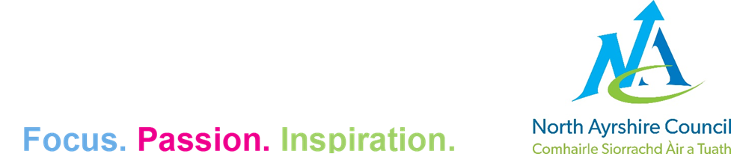

Contents
1. Parties to the Agreement
2. Scope of Agreement
3. Membership of LNCT
4. LNCT meeting arrangements
5. LNCT Agreements
6. Facilities time
7. Failure to agree
8. Variation to the Recognition and Procedure Agreement

Version Control
Version Number | Effective Date | Details of Last Revision
2.0 | 3 December 2025 | Updated Trade Union names and inclusion of grievance and disciplinary
1.0 | 15 February 2002 | Creation of document
Equality Impact Assessment: 22 January 2026
Prepared by: HR Team

Parties to the Agreement
  - This Local Recognition and Procedure Agreement (RPA) is between North Ayrshire Council and The Educational Institute of Scotland (EIS), The Scottish Secondary Teachers’ Association (SSTA), The National Association of Schoolmasters Union of Women Teachers (NASUWT), Community, School Leaders Scotland (SLS) and The Association of Head Teachers and Deputes in Scotland (AHDS).
  - All parties to this Agreement jointly affirm their commitment to the maintenance of good employee relations and accept that this Recognition and Procedure Agreement and any formal agreements which may arise from it will be binding on the signatory parties.

Scope of Agreement
  - North Ayrshire Council recognises the EIS, SSTA, NASUWT, Community, SLS and AHDS as the sole representatives of employees on Teachers and Associated Professionals Conditions of Service (as defined in the Scottish Negotiating Committee for Teaching Staff Handbook).
  - All agreements, orders, settlements and determinations of the SNCT dealing with:
- cover agreements
- appointment procedures
- particulars of employment
- expenses of candidates for appointment
- transfer of temporary teachers to permanent staff
- promotion procedures
- staff development arrangements
- specific duties and job remits
- arrangements for school-based consultation and negotiation
- other leave and absence arrangements
- notice periods
- housing
- indemnification procedures
- other allowances
- discipline and grievance procedures
- working time arrangements
shall be adopted as the base for negotiations under the procedures established by this Recognition and Procedure Agreement.
  - Negotiations between parties to this Recognition and Procedure Agreement will be conducted within a committee to be known as the Local Negotiating Committee for Teaching Staff (LNCT).
  - In addition to undertaking negotiations on conditions of service, the LNCT will also provide a means of regular consultation and exchange of information between the Council, Trades Unions and the teaching employees that they represent on a range of matters of mutual interest.

Membership of LNCT
  - The membership of each side of the LNCT shall be determined by the sides separately but shall not exceed nine members of each side. In addition, each side can invite an appropriate person to attend in an advisory capacity (they are not required to be a North Ayrshire Council employee and would have no right to vote).
  - The Council will negotiate through a management side, appointed by the council.
  - The recognised unions will negotiate through a joint trade union side appointed by them collectively which will reflect, on a pro-rata basis, the respective membership strengths of each union.
  - The management side and the joint union side will each appoint a secretary for their respective sides.
  - A nominated substitute member can attend meetings of the LNCT as advised.
  - The LNCT may, from time to time, appoint from among its own members a sub-committee or sub-committees to discharge such of the functions of the LNCT as the LNCT may specify.
  - The quorum for a meeting of the LNCT shall be three from the management side and three from the joint union side. in the case of a sub-committee, the quorum shall be determined by the LNCT when the sub-committee is established.

LNCT meeting arrangements
  - Meetings of the LNCT will be held when requested by either side, with a minimum of three meetings in each academic year.
  - The first meeting of the LNCT in each academic year will appoint the Chair and Secretary of the Management Side and Chair and Secretary of the Joint Trade Union Side. This meeting will also review any standing sub-committees.
  - The joint secretaries shall be responsible for making the arrangements for meetings which will be arranged within ten working days of a request being lodged, or otherwise by mutual agreement.
  - The Chair of LNCT meetings will alternate between the Chair of the Management Side and Chair of the Joint Trade Union Side each academic year.

LNCT Agreements
  - Members of the LNCT should make all efforts to reach agreement and all parties should be cognisant of the importance of establishing and maintaining confidence in the negotiating arrangements established under this Agreement which will be made in good faith.
  - A matter shall be agreed by the Committee only if approved by both sides based on a majority of each side present and voting.
  - Agreements reached by the Committee shall be binding on the Council and the recognised unions.
  - Agreements reached between the two sides shall be set out in writing jointly approved by the two sides and signed by the joint secretaries.
  - All local agreements shall be reported to the SNCT.
  - The joint secretaries will be available to advise their respective sides on matters relating to agreements reached by the Committee. In formulating such advice, the joint secretaries may consult with each other whenever they think it appropriate.

Facilities time
  - The Council agrees to ensure that adequate paid time off work shall be granted to all union representatives on the LNCT and that particular consideration shall be given to the amount of paid time off work required by the person appointed as union side joint secretary, as well as the necessary facilities as per ACAS Code of Practice on Time off for Trade Union Duties and Activities.

Failure to agree
  - In the event of any dispute being declared, the Council and the recognised unions will seek to resolve the matter, without delay through discussion in the LNCT. The Council further agrees not to implement any change which is the subject of dispute until the matter has been considered by the LNCT. The recognised unions agree not to implement any form of industrial action unless and until the LNCT has failed to achieve a resolution of the matter in dispute.
  - Where agreement is not possible either side may refer the failure to agree to the Joint Secretaries of the SNCT for conciliation.
  - If the conciliation is unsuccessful the Joint Secretaries to the SNCT may recommend further procedures for resolution of the difference, including external conciliation, mediation or binding ACAS arbitration.

Variation to the Recognition and Procedure Agreement
  - No variation to this Recognition and Procedure Agreement may be made except with the consent of both Sides to this agreement.

